MINI DV- YSB004
User Manual

Thank you for purchasing MINI DV—YSB-004. It has adopted chewing gum shape design, which makes it apply to every area. MINI DV—YSB-004 brings more convenience, safety and funs to your daily life.
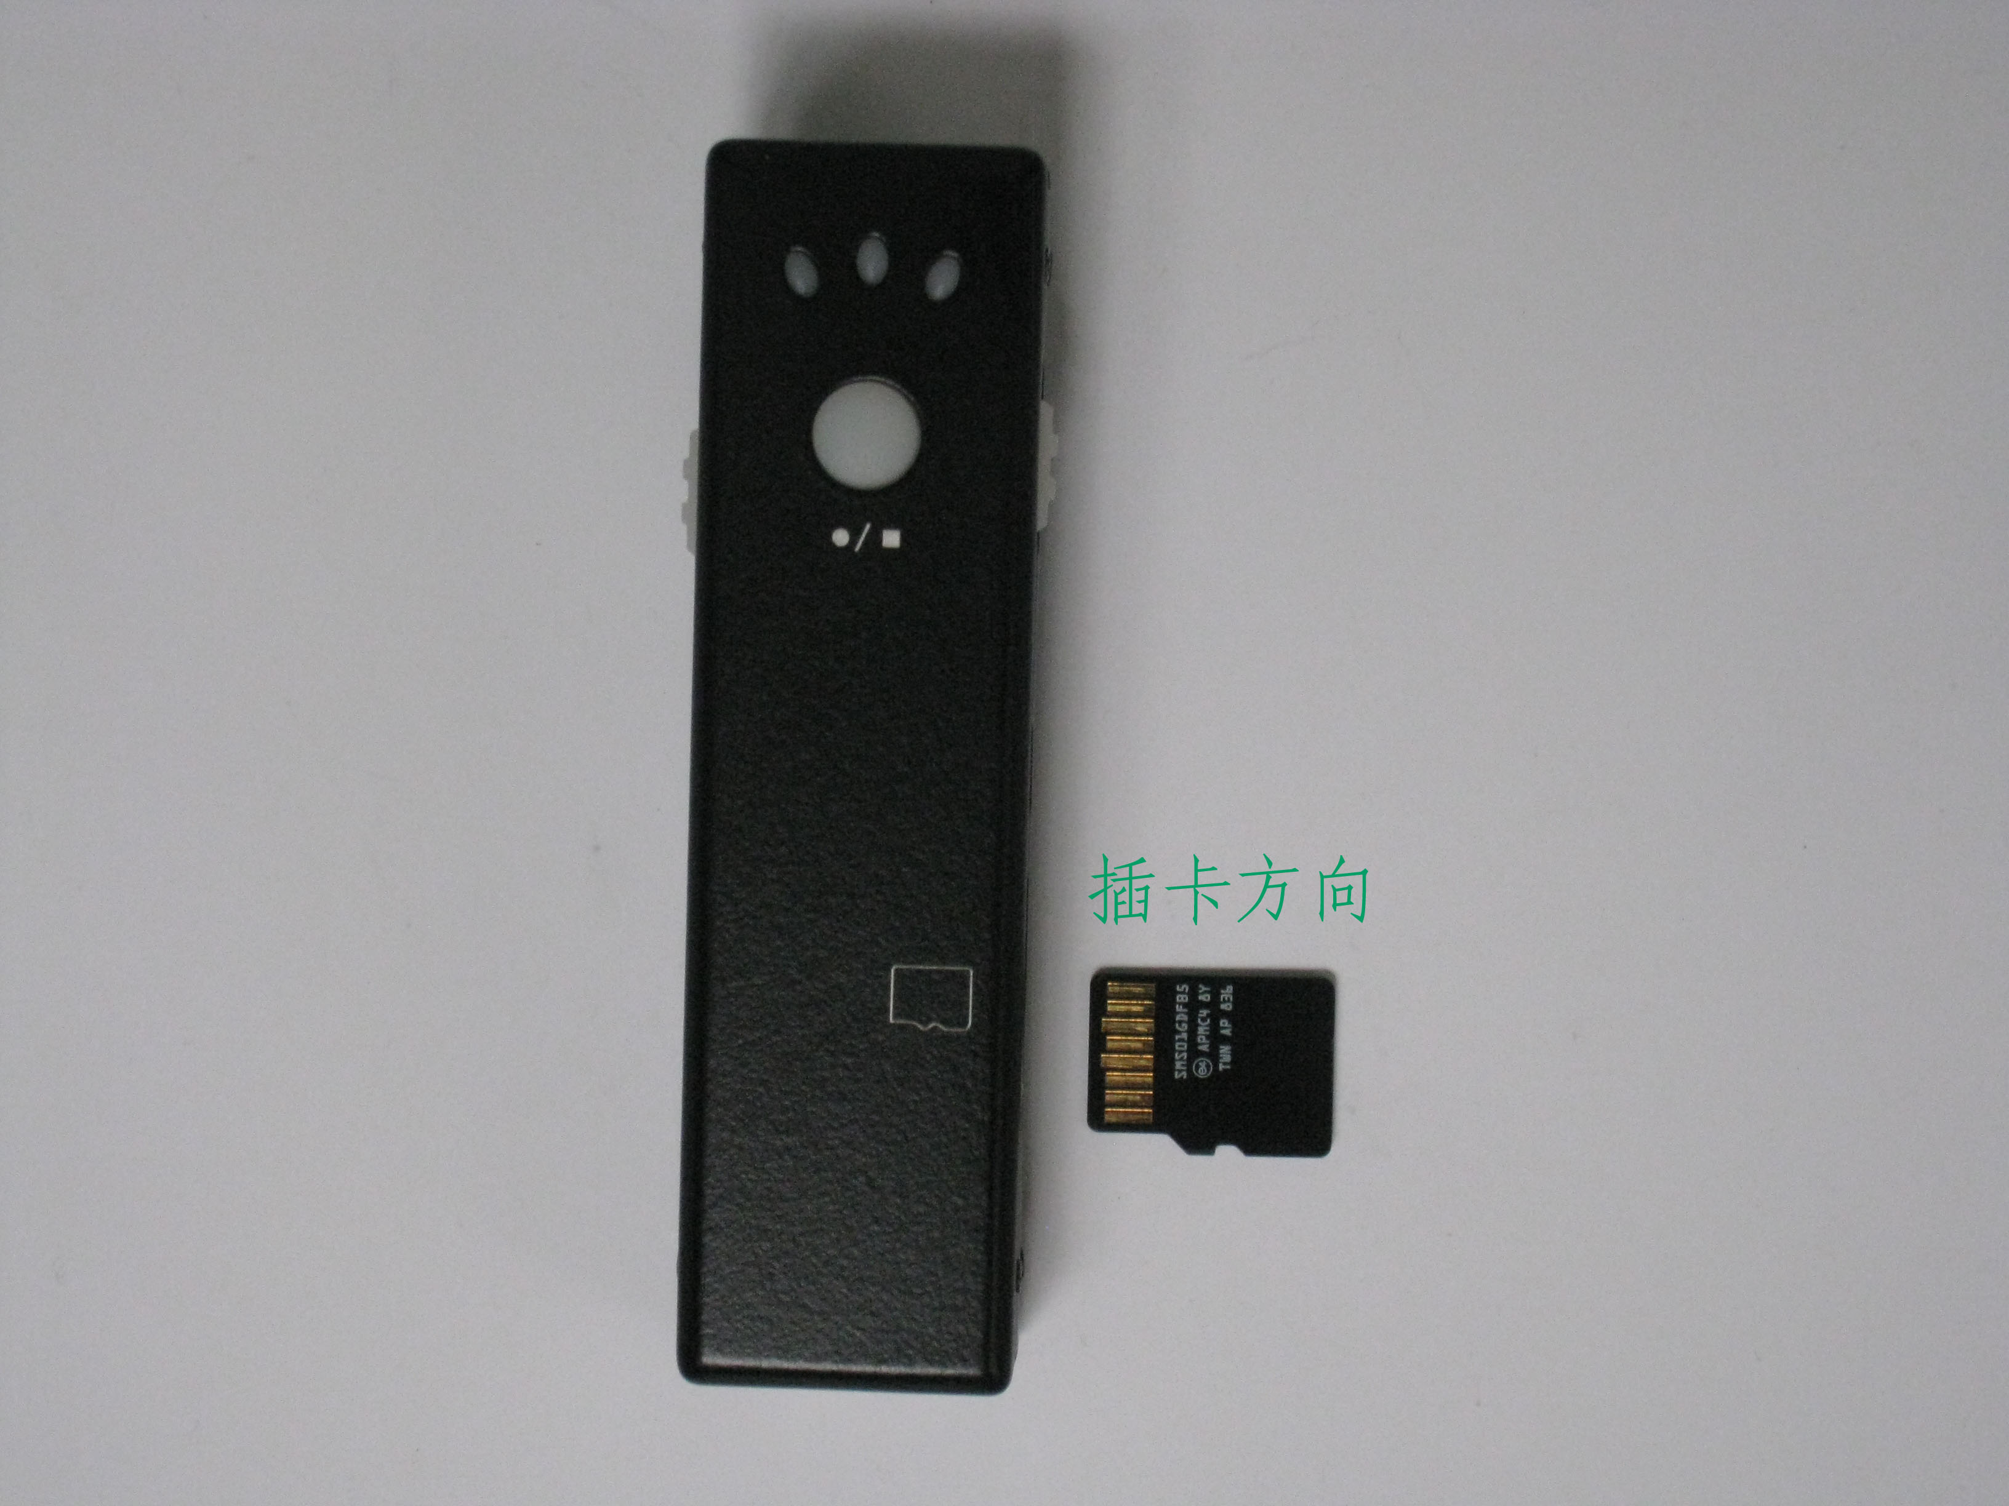

I Characters of Product
- It has small contour design, through the surface of the matte effect of treatment, Stylish fashion built for all-around wear.
- Support PC camera and chatting function.
- Support AVI video format.
- It can carry out high definition image recording under low illumination.
- Support 30 fps for 720*480 and 1280*1024 video shoot and output.
- Support USB1.1 and USB2.0.
- Support 8GB T-flash card.(maximum)
- Build-in lithium battery which can make a video more than two hours
II Operation Guide

1. Charge
The battery is built-in lithium rechargeable battery, so when you use it the first time, please charge firstly. The method for charging as following:
1.) Connect computer: use USB cable to connect the computer, then it can be charged.
2.) Use adaptor: connect charger plug with USB cable, then plug into electrical connector receptacle, it can be charged.
When you charge it, red indicator light starts to flash and red indicator light begins to brigh, the green light stops blinking when the when the battery is full.

Notice: when battery power is not enough, D006 will enter into protection mode, so it cannot be turn on. Now, please charge for it.

2. Power on to video
1）Push “ON/OFF” button to “ON”strike and move ‘Video/Photo” button to the “Video”,
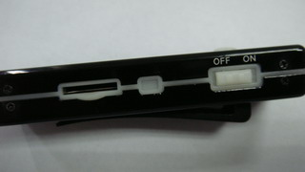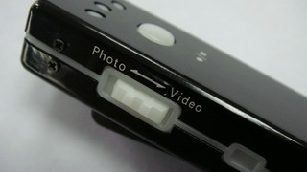
2）press “shutter” button will boot immediately green indicator light begins to bright. Press “Record/Stop” button, At this time, it begins to make a video. red indicator light starts to flash. The resolution for video file is 720*480, and frame number is 29--30fps/S.
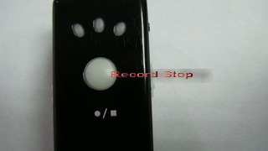

3）Then short press Record / Stop button, video is stopped and saved automatically. After saving the green indicator light remains light. If you need to continue to video, please press Record / Stop button slightly once more.

Notice:
a. Please make sure T-flash (Micro SD) card has been inserted, if not, it will be power off automatically after 20 seconds.
b. The maximum capacity of T-flash card is 8GB.
c. Saving file needs certain time, so please don’t press Operation button continuously in order to avoid saving unsmoothly and generating incomplete file.
d. When you make a video, please focus on the object and keep 50cm under sufficient illumination. Then the video will be right, natural color, clear and stable.

3. Take Photo
Push “ON/OFF” button to “ON”strike, and move ‘Video/Photo” button to the “Photo”, press “shutter” button will boot immediately green indicator light begins to bright. Press “Record/Stop” button. red indicator light flashing, represents a photo shoot and save. Photo resolution:1280*1024 Repeated press, repeat photo and save.

4．Time set
There is a CD with the product which contains a file named time synchronization file. Please copy it to TF card. When connect YSB-001 with computer, whose time will be displayed with computer synchronously.
The detail as following:
- build a text called TAG.TXT under root directory of card.
- open TAG.TXT,write synchronous date according to enclosure stricktly.
Details as following:
[date] need space with newline
2009/07/22 need space with newline
12：00：00
Power on the machine everytime, system will check and analyse TAG.TXT, then set system time according to file time. After that the text will be deleted by system automatically.

5．Power off
push “ON/OFF” button to “OFF”strike, then release till indicator goes out. Then the machine is turned off. Notice that as a video recording, please save the file first.

6. Auto-power off function
MINI DV will save file and turn off automatically as following:
a. When you shoot video without enough power, file will be saved automatically, then auto-power off.
b. When disk space of MINI DV is not enoughn, after indicator goes out immediately, file will be saved automatically then auto-power off.
c. Under standby mode, without any operation in 20 seconds, it will be auto-power off.

7．Connecting computer
It can connects computer under power off mode, standby mode or video mode, after that which can be used as U disk, who can copy, cut and paste, delete file.
When you connect it with USB port, a portable disk mark will be seen after several seconds. Red indicator light always brights, yellow indicator light will be from flashed quickly to always brights.

Notice:
a. When you connect computer, if the machine cannot be identified, or not see the portable U disk mark in 30 seconds, please insert it again.
b. It is better copy or cut video file into computer hardware then play. Video file which is saved in the machine is played directly will cause unsmooth play, the reason is that gigantic data cannot be transmitted synchronously.

8 PC Camera
When you first use PC camera, please install driver. The driver name is SPCA1528_V2220_M…Setup.exe, which is placed in attached CD. When you install please double press this document, and as per guide to do. After that there will be an AMCAP icon on the computer desk.
Under power off or power on mode, use USB cable to connect computer, the mode is U disk mode. Then short press “?” button, at this moment it can be switched into PC camera mode. Then double press AMCAP icon can be used as PC camera.

9．Reset
Push “ON/OFF” button to “OFF” strike, YSB-004 directly reset.

10. Notice
Suitable using situation: Please follow State's law. Do not use it illegally.
Work temperature: Please use it under normal temperature and avoid using under unsuitable body temperature.
Work humidity: Please use it under agreeable human atmosphere humidity, Please not to make product wet or expose in rain for which without waterproop function.
Shooting illumination: Please use it under enough light sources; do not aim the camera at the sun and other strong light sources in order not to damage optical parts of an apparatus.
Cleaning requirements: Please not use the product under too large dust density atmosphere so as not to affect video effects for tainted lens and other parts.
Waste treatment: Please pay attention to protect environment, not to throw the product optionally. In order to avoid explosion, please not throw product into fire.

